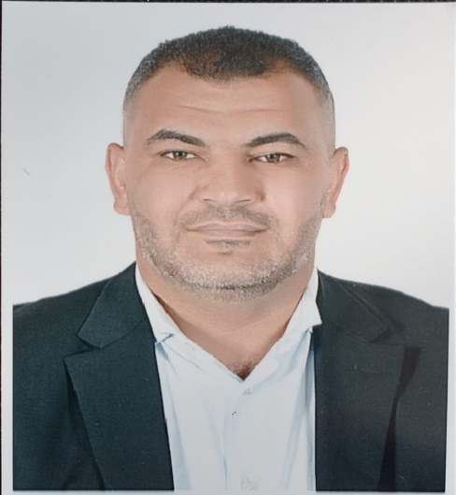 | AMER NAJI BANI YOUSEF  Dr. Finance and Banking / Financial Risk Management
CONTACT    Address  Balila, Jerash, Jordan  Date of birth: 20/12/1990    Phone number  00962779990046    Email  amermak90@gmail.com  SKILLS  • Demonstrated ability to convey complex ideas in a clear and understandable manner, adapting communication style to engage diverse audiences.  • Proficient in delivering lectures, leading discussions, and facilitating interactive learning experiences to promote student engagement and comprehension.  ** Computer skills:  - Microsoft Office: (Word, PowerPoint and Excel)  - Stata Data Analysis & Statistical Software (Stata)  LANGUAGES  - Arabic  - English  HOBBIES  - Soccer  - Reading  - Writing and publishing scientific papers | PROFILE  I am driven by a vision to impart intricate financial concepts in a manner that is both accessible and engaging, thereby cultivating a dynamic learning environment for students. Proficient in the application of state-of-the-art analytical tools and methodologies, I endeavor to deliver profound insights. My unwavering commitment lies in the promotion of academic excellence and the active contribution to the progression of knowledge within the domain of Finance and Banking.  EXPERIENCE  Assistant professor of Financial and Banking at Jerash University  Jerash University / Jordan / 12 March 2024 – present.  EDUCATION  🎓 (August 2023)  UNIVERSITI MALAYSIA TERENGGANU, MALAYSIA, TERENGGANU.  PhD in Finance and Banking / Financial Risk Management.  Thesis Topic: (THE MODERATING EFFECT OF OWNERSHIP STRUCTURE ON THE INFLUENCE OF FINANCIAL RISKS AND RISKS DISCLOSURE ON FINANCIAL PERFORMANCE: EVIDENCE FROM THE MENA BANKS).  🎓 (September 2017)  THE WORLD ISLAMIC SCIENCES AND EDUCATION UNIVERSITY, JORDAN, AMMAN.  MA in Islamic Banking.  (Comprehensive exam)  Research Topic: (Banking Industry and Major Risk Faced: A Case Study of Jordan)  🎓 (September2013)  JADARA UNIVERSITY, JORDAN, IRBID.  BA in Accounting  Research Topic: Tax evasion in private companies and how to reduce it in the city of Irbid (Al-Hassan Industrial City)  PUBLICATIONS  1- Credit Risk and Financial Performance in the Middle East and North Africa Banks, Journal of Tianjin University Science and Technology, Published. Vol: 55 Issue: 06:2022  Amer N Bani Yousef, Roshaiza Taha, Siti Nurain Muhmad. (2022).  DOI 10.17605/OSF.IO/4RA5D  2- Operational Risk and Financial Performance in the Middle East and North Africa Banks, Journal of International Studies, Published.  Yousef, A. N. B., Taha, R., Muhmad, S. N., & Zainul Abidin, A. F. (2023). Operational Risk and Financial Performance of Banks in the Middle East and North Africa. Journal of International Studies (JIS), 19(2), 93-118.  3- The Impact of Market Risk Exposure on Banks' Financial Performance: Evidence From MENA Region, Management and Accounting Review, Published.  Bani Yousef, A. N., Taha, R., Muhmad, S. N., & Zainul Abidin, A. F. (2023). The impact of market risk exposure on banks’ financial performance: evidence from the MENA region. Management & Accounting Review (MAR), 22(2), 229-251.  4- Foreign Exchange Risk and Bank Performance: Evidence from Mena Banks, Journal of Chinese Economic and Business Studies, Under Reviewer.  5- Green finance and its impact on achieving sustainable development, Uncertain Supply Chain Management. Published 25/4/2024.  Mohammad Abdel Mohsen Al-Afeef, Baliira Kalyebara, Nawaf Abuoliem, Amer N. Bani Yousef and Mahmoud Abdel Muhsen Irsheid Alafeef (2024).  6- The impact of FINTECH on banking performance: Evidence from middle eastern countries. International Journal of Data and Network Science. Accepted: June 8, 2024  Mohammad Ali Alafeef, Baliira Kalyebara, Nevin Youssef Kalbouneh, Nawaf Abuoliem, Amer N. Bani Yousef and Mohammad Abdel Mohsen Al-Afeef (2024).  TRAINING COURSES  1- Recent trends in the banking business, lrbid- Jordan 8/8/2015.  2- Employability skills Program, Dale Carnegie Training, - lrbid- Jordan, 75 hours- May/ 2017.  3- Research methodology, University Malaysia Terengganu, Malaysia, Terengganu / 2019.  4- Workshop of Postgraduate Research, University Malaysia Terengganu, Malaysia, Terengganu / 2020.  5- ICDL, Jordan, lrbid, 22/12/2012.  CONFERENCES  - The 6th International Conference of Accounting, Business, and Economics (ICABEC 2020).  - 2nd FBESD Postgraduate Colloquium Team, (2nd Postgraduate Colloquium 2022).

