CURRICULUM VITAE
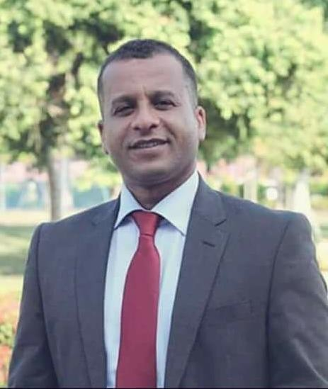
Mohd Saleh Shattyyan Mahafdah Ph.D.in Environmental Technology and Management

PERSONAL INFORMATION
Date of birth: 1 May 1977
Place of birth: Safi-Karak, Jordan Citizenship: Jordanian
Marital status: Single
Email: mmahafdeh@ahoo.com
Mobile: 00962790393066 - 00962795149332

ACADEMIC QUALIFICATIONS

- Doctor of Philosophy in Environmental Technology and Management,University Malaysia Terengganu, Malaysia, 2018. Major Field: Water Resources Management.
Dissertation Title: “Climate Change Impact on Water Resource Management in Southern Part of Dead Sea Region-Jordan”.

- Master Degree in Environmental Science and Management,University of Jordan, Jordan, 2012, (Very Good).Major Field: Water Resource Management.
Dissertation Title: “Irrigation Water Management in Ghor Safi Area”.

- Bachelor Degree in Botany, Aligarah Muslim University, India, (Second Division).

EXPERIENCE

- Research Assistant, University Malaysia Terengganu, Malaysia, March 2016 - February 2018.

TEACHING EXPERIENCE

I have taught different courses in Science topics at the Secondary School level. These courses are listed below:
- Biology
- Chemistry
- Earth Science
- Physics

RESEARCH INTERESTS

- Water Resource Management and Water Management Modelling
- Irrigation and Drinking Water Management
- Climate Change
- GIS, Prediction and Forecasting Models
- Eco- systems and EIA, Environmental Studies

PUBLICATION
- Mahafdah.(2022). Irrigation Water Management In Semi-Arid Regions-Case Study Jordan. Syboldreport,17 (09),1500-1510.
- Mahafdah and Sathiamurthy.(2022). Perception of Farmers on Irrigation Water Management in Semi-Arid Region Impacted by Climate Change-A Case Study of Southern Dead Sea area, Jordan.Syboldreport,17 (09).2058-2075.

REFERENCES

- Elias Salameh, Professor of hydrogeology and hydrochemistry,at the University of Jordan, Jordan. E-mail: salameli@ju.edu.jo.

- Edlic Sathiamurthy, Associate Professor of Hydrology, at School of Ocean Engineering, University Malaysia Terengganu. E-mail: edlic72@gmail.com.

- Marwan M. Al-Raggad, Associate Professor of Hydrology, Climate Change and GIS. Water, Energy and Environmental Center. University of Jordan, Jordan. E-mail: mar_raggad@yahoo.com.

