Dr: Khaled Hamadin | 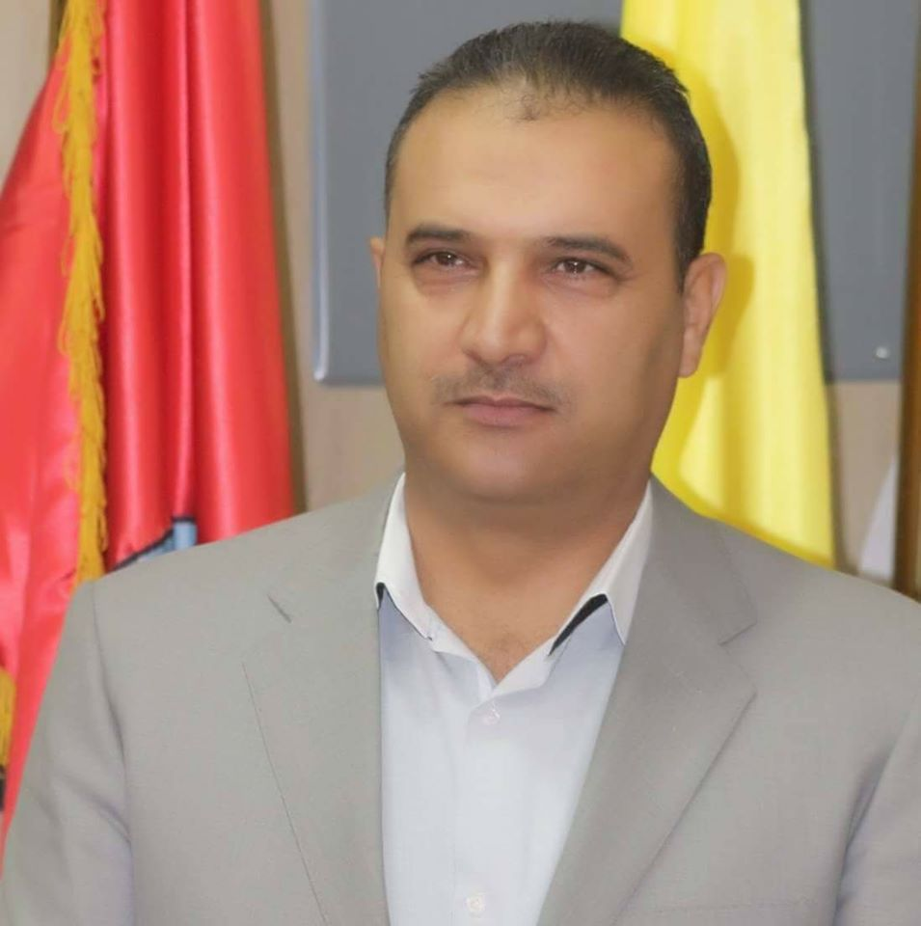
Email:Khamaden72@yahoo.com
HP; 00962799858171

General Major/ Specialization: Educational Leadership and Management

Qualifications:

Educational Leadership and Management /University Since of Malaysia (USM) | PhD
Educational Management/ University Since of Malaysia (USM) | Ma
Educational Studies  Objective: To inspire and prepare youth to become productive members of their society and accelerate the development of the national economy. | Deg

 | To | From |  | #
Assistant Professor Educational leadership/Jerash University  Department of Graduate Studies | -------- | 2019
-Assistant Professor Educational leadership/ At Meddle East University (MEU)- Jordan .  Chairman Committee of Quality Standard /Community Service and External Relations.  Member Committee for attracting foreign students.  Member of follow-up (Registration Department) and academic guidance for undergraduate and graduate students.  Volunteer assistant students to complete leadership and projects internship.  Volunteer to teach students on communication skills Leadership skills Skills in business ethics and community leadership skills | 2019 | 2018 |  | 1
Assistant Professor Al- Zarqa University – Jordan. | 2018 | 2016- |  | 2
Lecturer Educational Leadership and Management –Balaqa University –Jordan  (Jordan Hashemite Fund) for the support of Badia work of voluntary programs to serve the associations that were university in the( desert region) | 2015 | 2014 |  | 3
Trainer /Institute of Public Administration Jordan Government Sector) –Jordan, following programs:  - Capacity Building Central Administration (Assistant Director).  -Change Management, time management and work ethics. | Part time | 2015 |  | 4
Teacher School/Arabic School –Malaysia | 2011 | 2011 |  | 6

Skills, achievement and Awards
1-Reviewer. International Journal of Education, Culture and Society, JER, USA
2-With Injaz The programs below: .” INJAZ nonprofit Jordanian organization, has established itself as a leading solution provider linking the public, private, and civil society sectors to bridge the skills gap between the educational system and the changing needs of the labor market as below
a- My Entrepreneurial Project (MEP)
b- Young Volunteers' –youth engagement –gender considerations
c- Company Start-up Program- Schools & Competition
D-Presentation Skills (PS) & Competition
f- Applied scientific research project
G-Skills development for administration (Training @Consultation)
h-We Are Community Leaders
K-Ethics leaders (Training @Consultation)
3-Scientific Research Support Project. Award about Implementation of E- learning applications in educational crisis management ( Deanship of research).
4-A project initiative with cooperation with the Ministry of Education (The idea of training students in writing, publishing and ideas about projects of interest to the local community.
B-Generation program. Creating a creative leadership generation by involving school students in building society
5-Certificate from British Council the Interim Language Survey (ILS) Academic skills course.
6 Certificate from President University to achieving the goals and vision of Guidance of Career Office and Follow-up Alumni/ King Abdullah II Fund (KAIF).
7-ICDL International Computer Driving License.
8- Award from University President for working to achieve the university vision
9-Acknowledgment of the President of the University of the Middle East on the achievement of the criterion of community.
10-A representative of Jerash University to finding academic and research partnerships with Australian universities
11-A representative faculty of education in concluding training agreements with local community organizations and foreign organizations.
Community Activities/Involves

 | With | #
Project Design and proposal writing.  -Project strategy –monitoring and evaluation –smart objectives | With USAID FHI360 | 1
TOT Trainer Of Trainee | Erada International Academy | 1
Presenter Family Reform /in cooperation and conducted with Department of the Chief Justice(A curriculum to help families live a strengthening relationship | Corporation with world relief Germany | 2
Time management workshop with King Abdullah fund –Zarqa University Presenter | With royal court | 3
Presenter work ethics workshop with INJ AZ –Al Zarqa University | Injaz | 4
-Capacity building to Administration Mangers  -Strategic planning -- | (Institute of public administration ) | 5
Trainer as volunteer The national platform for youth volunteering and participation | Ministry of Youth
Leadership training for manger (online)  LEADERSHIP  TRAINING  FOR MANAGER  LEADERSHIP  TRAINING  FOR MANAGER  LEADERSHIP  TRAINING  FOR MANAGE | DALE CARNEGEI | 6

Professional @Personal Development Workshop conducted - Malaysia
1. Literature Review @Organizing Search Results Using End Note
2. Data Analysis Theoretical Section
3. Qualitative Data Analysis Using Nivivo
4. Literature Review @Organizing Search Results Using End Note Part 2
5. Strategies To Get Published
6. Raising Employ Ability
8. Data Analysis Part 2
9. Quantitative Analysis Work Shop
10. Structural Equation Models By Amos Introductory Level
12. Structural Equation Models-Intermediate Level
13. Leadership and Work Values
15. Workshop about Rush Model
16. Workshop about Response Theory
17. Multiple Regression Analysis
18. Introduction to research methodology
19. Item response theory
20. Data Management @ Plagiarism

Publications:
Year/ Issue (Vol/No) | Publisher | Title | #
www.ajrsp  26/3/2020 | The academic journal of research and scientific publishing | The family of support and its relationship to academic achievement at secondary Jordan schools.
Special Issue. 4, pp: 191-198, 2018 | Academic Research Publishing Group | The A Proposed Model of Activating Institutional Governance at The Middle East University from Faculty Members’ Point of View
ISSN 2162-6952 2018, Vol. 8, No. 4 | Journal of Studies in Education | Evaluation of The National Council for Accreditation of Teacher Education (NCATE) Al-Taif University and The Middle East as Model
Journal of Education and Practice www.iiste.org  ISSN 2222-1735 (Paper) ISSN 2222-288X (Online)Vol.8, No.11, 2017 | international institute forScience and Education (IISTE) | - Implementation Of E-Learning Among Jordanian Schools Management.
Vol 5, No 28 (2014) | Journal of Education and Practice www.iiste.org | The Professional Academic Requirements for the Kindergartens Female Teachers in South of Jordan and Knowing the Effect of the Scientific Qualification and the Experience on These Needs.
Volume 2, JUNE 2014, Jordan | Al-Hussein Bin Talal Journal of research AHUJ, | The Relationship between Practicing Knowledge Management Processes and the Effectiveness of Administrative Decisions Made by Schools' Principals in Ma’an Governorate.
.. IJERT: Volume 5 [4] December 2014: 68-75 | International Institute for Science, Technology and Education (IISTE) | - The Professional Academic Requirements for the Kindergartens Female Teachers in South of Jordan.

Main Supervisor of Master theses
The Degree of The Public Schools' Principals Dealing with the Scholastic Bullying in Directorate of Education inAl-Azraqa Second Region From the Teachers 'Point of View Prepared by: Suleiman Badran Al-Khawaldeh Supervisor Dr. Khaled Mohammed Al-Hamadeen. The discussion was remotely(online) . Use the Zoom application2020.
-Servant Leadership That Practiced By Governmental Secondary School Principals in Madaba Student name Ola Mohammed specialization of management and leadership 2019
-Strategic Orientation of Presidents of Jordan Universities in Amman-- student Fadi Al Titi 2019
--The Degree of Leadership Practice in Faith and Its Relation to Moral Decision-making Among The Principals of The State Secondary Schools in Madaba Governorate from The Point of View of Teachers and Administrators…………. Student Name Asma Al Sawadeh 2019
External Examiner
Management by values and its relationship to the organizational commitment of principals of
Private basic schools in the capital Amman, from teachers 2020 (online by Zoom)

Internal Examiner
-Member of the internal discussion committee, specializing in the administration and leadership of student Asra Abu Asba 2019
-Member of the internal discussion committee, specializing in the administration and leadership of student Nessren Al Aaraj 2019
-Leadership Ability in Government School in Amman and its Relationship from middle leader point of view Student Name –Eman Amerah 2019
-The Degree Of Strategic Entrepreneurship Practice Of Secondary School Principals in the capital Amman Governorate and its relation to the organizational trust …. Afnan Zabt 2019.
Committee
Committee Chairman the Service and External Relations Meu
-Committee member Faculty of Education, Al Zarqa University in the development of Master digital educational leadership.
-Committee Of Head Quality and Development, , Al Zarqa University
- Committee Of Head the Social and Culture. Al Zarqa University
-Committee member of the Quality Committee, Al Zarqa University.
-Committee member of the Commission to develop a Curriculum student ethics Al Zarqa University.
-Collaborate with Deanship Registration Tips and Guidance for New Students.

Conference
- Educational and Training Program – Australia –Sydney
-Effective Culture Of Measurement And Evaluation In Learning Organization (ICMEE) Malaysia.

Teaching Courses master
-Knowledge management and creativity
-Principles of School Management
-Leadership and Management
-educational supervision
- Educational leadership
Teaching Courses BA Degree
-Research Methods
-Educational Studies
_ University student code conduct (Ethics University Student)
- School Principals Leadership
- School Managements service and external disabilities quality award.

Reference
Deputy Dean of educational studies and arts | Associate Prof | Expertise | 1- Mohammed Badwi | Name and position
Phone 00962788191241 | mbadawi@zu.edu.jo | E-Mail | Zarqa University-Jordan | Address
Dean Of Arts | Dean |  | Prof.Alla Sadek | Name and position
Phon00962796684488 | Alaeddin71@yahoo.com | E-Mail | Zarqa University-Jordan | Address
009626279723351 | Supervise | Expertise | Fadi Farahneh | Name and position
009627972333 | Ffarahneh@unjaz.org.jo | E-Mail | INJAZ/Amman-Jordan | Address

