CV
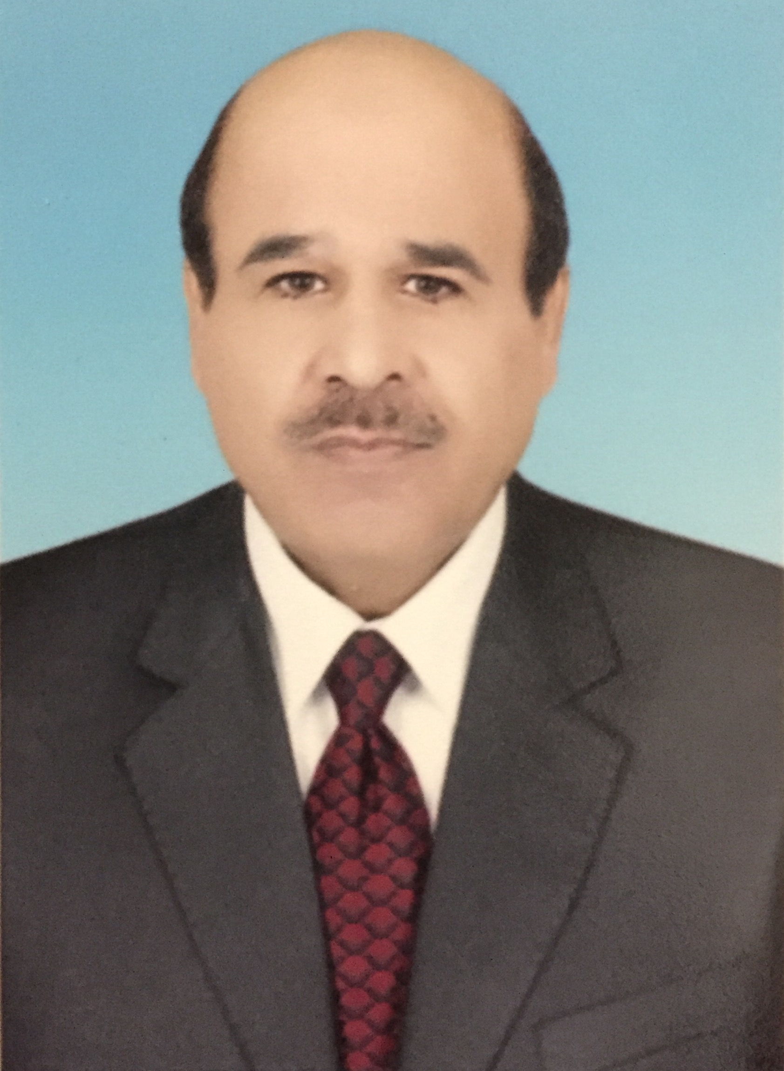

PERSONAL DETAILS
Name | Ali Jaddo' Bkhitan Al-sharafat
Gender | Male
Date of Birth | 1 / 2 / 1959
Nationality | Jordanian
Religion | Islam
Current Marital Status | Married
No. of Children | 3
Mobile | 0795709403
E-mail | alijerash@gmail.com  Bkhitan2@yahoo.com
Permanent Address | Jordan-Mafraq, Northern Badia, Salhyya

EDUCATIONAL QUALIFICATIONS
1999 - 2002 | PhD in Agricultural Economics & Agribusiness. University of Jordan,  Faculty of Graduate Studies.
1994 - 1996 | Master in Animal Production & Protection. University of Jordan,  Faculty of Graduate Studies).
1989 - 1991 | Diploma in Animal Production & Protection. University of  Jordan, Faculty of Graduate Studies).
1978 - 1982 | Bachelor in Animal Production & Protection. University of Jordan,  Faculty of Agriculture.
1975 - 1978 | 1st, 2nd & 3rd secondary classes. Zarqa Secondary School.
1966 – 1975 | Primary 1st-9th Classes. "Hitteen" & "Alwaleed" schools in Zarqa.

EMPLOYMENT HISTORY
October 2008 -up-to-date | Jerash Private University – Jerash:  - Academic Staff Member/Faculty of Agriculture (2008 -up-to-date).  - Climate Change & Sustainable Policy Project Coordinator (2013-  up-to-date).  - Manager of Consultancy Center (2012- up-to-date).  - Supervisor of Quality Assurance Office/ Faculty of Agriculture (2009-  2012).
March 2007 - up-to-date | Jana for Consultancy and Studies – Amman: Researcher & Consultant.
October 2006 - March 2007 | Jordan International Police Training Center (JIPTC)-Amman:  Translator.
January 2006 - July 2006 | Balqa Applied University, Qurtoba Private Community Girls  College: Part time Lecturer.
March 2003 – August 2004 | Ministry of Education, Jordan, Principal of Vocational Secondary  School.
August 1999 - March 2003 | Ministry of Education, Jordan: Coordinator, teacher and trainer  in Agricultural Section in Vocational Secondary School.
December 1986 - August 1999 | Ministry of Education, Jordan, Teacher of General Sciences (Biology,  Chemistry and physics).
January 1985-  December 1986 | Private Veterinary Company; Sales Representative.
January 1983 - January 1985 | Jordanian Armed Forces.

SKILLS & QUALITIES
Languages | Fluent in Arabic & English.
IT Skills | Very Good in basic computer applications & statistical analysis.
Qualities | Leadership, good communication skills, commitment, passion for work, hard worker, self motivated, ambitious, team player and able to learn.

CAPABILITIES
1. | Conducting economic analysis
2. | Constructing research questionnaires
3. | Preparing data for economic analysis
4. | Explaining analysis results
5. | English – Arabic translation & vice - versa
6. | Report writing & proposals preparation.
7. | Teaching abilities for all stages.

ACHIEVEMENTS
BOOKS
1. | Climate Change & Sustainable Policy; 2015.
2. | Environmental & Agriculture Science; 2015.
3. | Food in our Life; 2015.
4. | Principles of Microeconomics; 2012 ( In English).
5. | Introduction to Agricultural Economics; 2012.
6. | Introduction to Statistics; 2011.
7. | Principles of Marketing; 2010.
8. | Economic Development in the Arab World; 2010.
9. | Agricultural Insurance; 2007.
10. | Principles of Agricultural Economics; 2006.
11. | Fundamentals of Microeconomics; 2006.
PAPERS
1. | The role of SMEs in Economic Development in Jordan; 2015.
2. | Estimation of a Long-Run Cost Function for Bananas Cultivation in Jordan. Asian Journal of Agricultural Extension, Economics and Sociology; 2015.
3. | Technical Efficiency of Dairy Farms: A Stochastic Frontier Application on Dairy Farms in Jordan. Journal of Agricultural Science; 2013.
4. | Economic Analysis of Different Broiler Farm Capacities: A Case Study of Jordan. International Journal of Business and Management; 2013.
5. | Loan Repayment Performance of Public Agricultural Credit Agencies: Evidence from Jordan. Journal of Agricultural Science; 2013.
6. | Attitudes of Vegetable Farmers Towards Public Agricultural Extension Services;  2012
7. | A comparative Economic Analysis of Sheep Production Systems in Jordan; 2012.
8. | Factors Affecting Profitability of Layer Hens Enterprises; 2012.
9. | Effectiveness of Agricultural Extension Activities; 2012.
10. | Evaluation of Vegetables Farmers Participation in Agricultural Extension Activities; 2012.
11. | Economics of Raising Local Goat in Jordan; 2011.
12. | Applying Linear Programming Technique to Formulate Least Cost Balanced Ration for White Eggs Layers in Jordan; 2011.
13. | Risk Level in Broiler Production in Jordan; 2009.
14. | Marketing Margins of Broiler Industry in Jordan; 2009.
15. | Attitudes of Producers Toward Livestock Insurance in Broiler Industry  in Jordan; 2009.
16. | Financial Feasibility of Organic Fertilizer Production in Jordan; 2009.
17. | The Effect of Ca Level, Microbial Phytase and Citric Acid on Performance Parameters  Eggshell Quality of Laying Hens Fed Corn Soybean Meat Diets; 2009.
18. | Environmental Impact Assessment Study and the Economic and Social Council for the Yarmouk River Basin Project / Ministry of Agriculture, 2008.
19. | Agricultural Insurance; 2007.
20. | A Strategy for National Agricultural Vocational Training; 2005.
21. | Improving the Financial Performance of Broiler & Egg Producing  Farms in Mafraq and Zarqa Governorates;2002(PhD Thesis).
22. | Econometric Analysis of Demand Functions for Four Kinds of  Vegetables in Jordan; 2001.
23. | The Agricultural Sector in Jordan under EU-Jordanian Partnership  Agreement; 2000.
24. | Wastewater as an Extra Ordinary Source of Water in Jordan; 1999.
25. | Factors Affecting Sheep Productivity in Northern Badia of Jordan; 1999.
26. | Effect of Flock Size on Sheep Producers Income in Northern Badia of  Jordan; 1998.
27. | Livestock & Livestock Products Marketing in Jordan; 1998.
28. | Sheep Production Systems in Northern Badia of Jordan; 1996.(Master Thesis).
29. | Many Agricultural workshops and seminars, and many published topics  in local newspapers and in The Agricultural Engineer magazine.

FEASIBILITY STUDIES
1. | Study of economic and environmental feasibility of the draft pool commercial stores  and services to the municipality Salhia / Development Bank towns and villages/ 2008.
2. | Study of economic and environmental feasibility of the draft banqueting hall and  multi-purpose hall of the municipality Salhia / Development Bank towns and villages/ 2008.
3. | Study of economic and environmental feasibility of the draft Municipal kindergarten  Salhia / Development Bank towns and villages /2008.
4. | Study of economic and environmental feasibility of the draft for fattening and breeding  sheep /Municipality of Salhia / Development Bank towns and villages/ 2008.
5. | Study of economic and environmental feasibility of the draft saw the cornerstone of the Safawi municipality / Development Bank towns and villages/2008
6. | Study of economic and environmental feasibility of the draft cultivation 500 acres Balpersem Alhijazi Safawi municipality / Development Bank towns and villages/2008.
7. | Study of economic and environmental feasibility of the draft Municipal kindergarten Safawi municipality / Development Bank towns and villages/2008.
8. | Study of economic and environmental feasibility of the draft Mtp. fuel /Safawi / Development Bank towns and villages/2008
9. | Study of economic and environmental feasibility of the draft plant brick tiles and the mayor of Deir Al-Kahf / Development Bank towns and villages in January 2008.
10. | Study of economic and environmental feasibility of the draft Youth Club and a football stadium for the mayor of Deir Al-Kahf / Development Bank towns and villages/2008.
11. | Study of economic and environmental feasibility of the draft saw limestone Ruweished Municipality / Development Bank towns and villages in January 2008.
12. | Study of economic and environmental feasibility of the draft cultivation 500 acres Balpersem Alhijazi Ruweished Municipal / Development Bank towns and villages/2008.
13. | Study the economic feasibility and environmental implications of the project of building a hotel to the municipality of Ruweished / Development Bank towns and villages/2008.
CONSULTANCY SERVICES PROPOSALS
1. | Technical and financial Consultancy Services Proposal for commercial stores and offices in Bait Ras and Tafeelah /Ministry of Awqaf and Islamic Affairs/2010.
2. | Assessment of the Risks from Climate Change and Water Scarcity on Food Productivity/Food and Agriculture organization of the United Nations (FAO)/ 2010
3. | The Turkmanniyya road transportation plan: Social and Environmental impact assessment/ 2010.
4. | Environmental Impact Assessment and Feasibility Study for Production of Irrigated Forage Crops in the North Eastern of the Jordanian Badia/2010.
5. | Preparation of the Second Jordan Competitiveness Report 2008 – 2009.
6. | Identify and Screen Adaptation Measures to Reduce Climate Change Impacts on  Food Productivity/ Food and Agriculture organization of the United Nation/ (FAO)/2010.
7. | Evaluation of the Performance of The National Fund for Enterprises Support  (NAFES)/ 2009.
8. | Preparation of a Socio-Urban Place Research for the Jabal Amman Residents  Association/2009.
9. | Management and Business Development Services Proposal for Louis Berger Group, Inc./2009.
10. | Consultancy Services Proposal:"Jordan's Second Investment Map"/2009.

TRAINING
March-2012 | Strategic Planning, Jerash University.
December –2009 | Academic Staff Development, Jerash University.
February –2009 | Measurement & Evaluation, Jerash University.
August – October 2004 | ICDL, Agricultural Engineering Organization, Amman.
August –September 2003 | New Principals Training, MOE, Jordan.
School Year 1991/1992 | Teaching Methods II, MOE, Jordan.
School Year 1990/1991 | Teaching Methods I, MOE, Jordan.

INTERESTS
Agricultural Economics, Pure Economics, Management, Agricultural Insurance,
Agricultural and Economic Development, Animal Production, and any other related topics.

REFERENCES
1. | Dr. Mahfouz Abu Zanat, Univ. of Jordan (06/ 5355000).
2. | Dr. Mohammad Alawaideh, Ministry of Agriculture. (0799028416).
3. | Dr. Ayman Salti, Ministry of Agriculture (0795679794).

